**Practice on Power BI**

# **Get started with Power BI Desktop**

1. Power BI Desktop are icons for the three Power BI Desktop views: **Report**, **Data**, and **Model**, from top to bottom.
2. Power BI Desktop also includes the **Power Query Editor**, which opens in a separate window. In **Power Query Editor**, you can build queries and transform data, then load the refined data model into Power BI Desktop to create reports.
3. **Power platform use?**
4. We can adjust the data to meet your needs. To shape data, you provide Power Query Editor with step-by-step instructions for adjusting the data while loading and presenting it. Shaping doesn't affect the original data source, only this particular view of the data.
5. **Shaping** can mean transforming the data, such as renaming columns or tables, removing rows or columns, or changing data types.
6. Power Query Editor captures these steps sequentially under **Applied Steps** in the **Query Settings** pane.
7. First, you specified a web source, and then you previewed the table in the **Navigator** window. In the third step, **changed type**, Power BI recognized whole number data when importing it, and automatically changed the original web **Text** data type to **Whole numbers**.
8. If you need to change a data type, select the column or columns to change. Hold down the **Shift** key to select several adjacent columns, or **Ctrl** to select non-adjacent columns. Either right-click a column header, select **Change Type**, and choose a new data type from the menu, or drop down the list next to **Data Type** in the **Transform** group of the **Home** tab, and select a new data type.

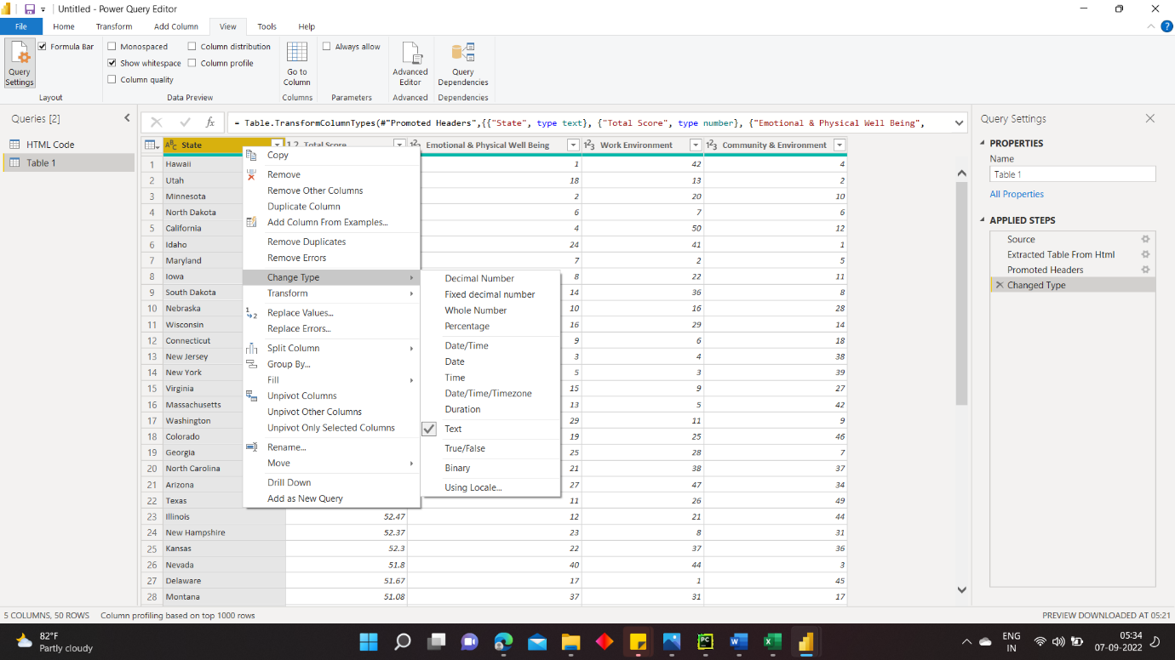

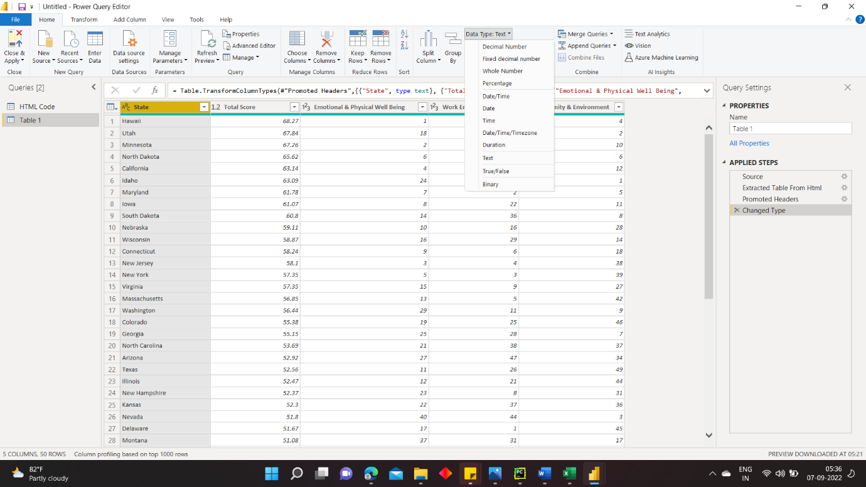

1. Suppose we didn’t want worst score in the table, to remove it we perform.

From the **Home** tab, select **Reduce Rows** > **Remove Rows** > **Remove Bottom Rows**. In the **Remove Bottom Rows** dialog box, enter 10, and then select **OK**.

1. The bottom 10 worst score rows are removed from the table, and the step **Removed Bottom Rows** appears in **Applied Steps**.

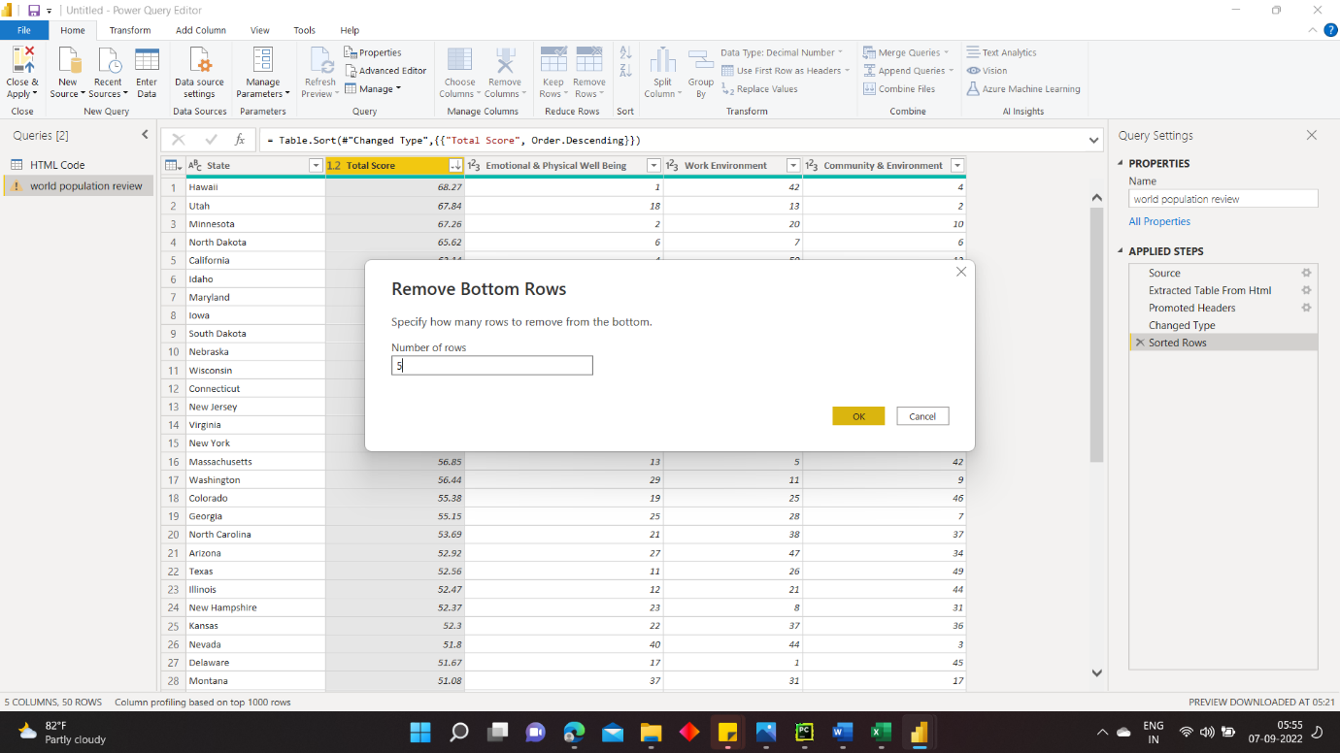

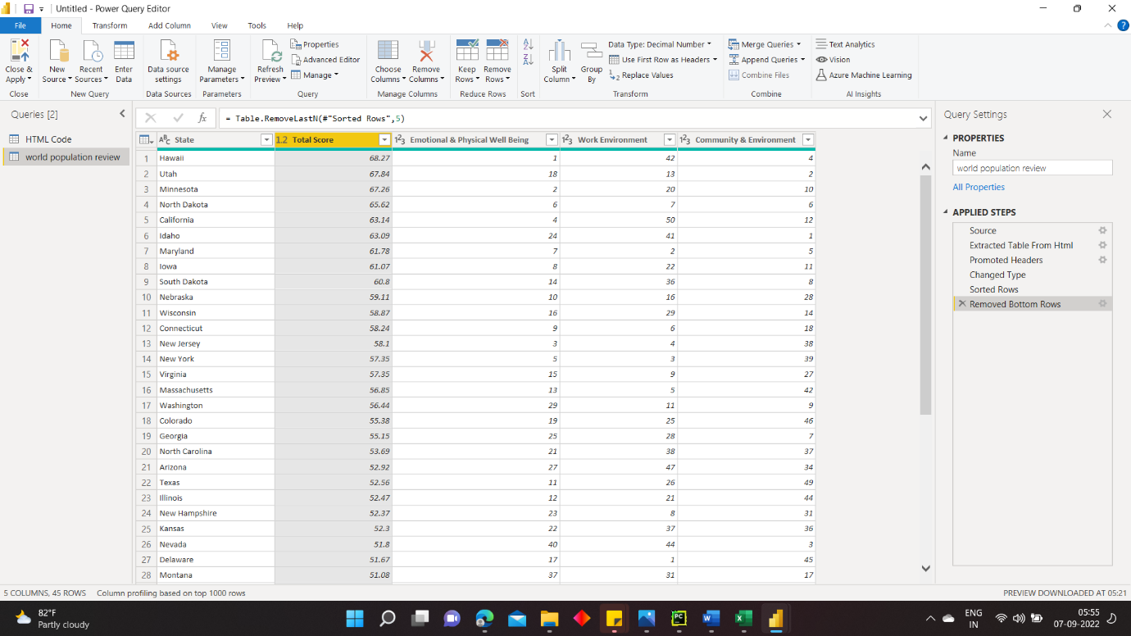

1. If we decide the table has too much extra information for your needs, and to remove the work environment columns.
2. Select the header of each column that you want to remove. Hold down the **Shift** key to select several adjacent columns, or **Ctrl** to select non-adjacent columns.

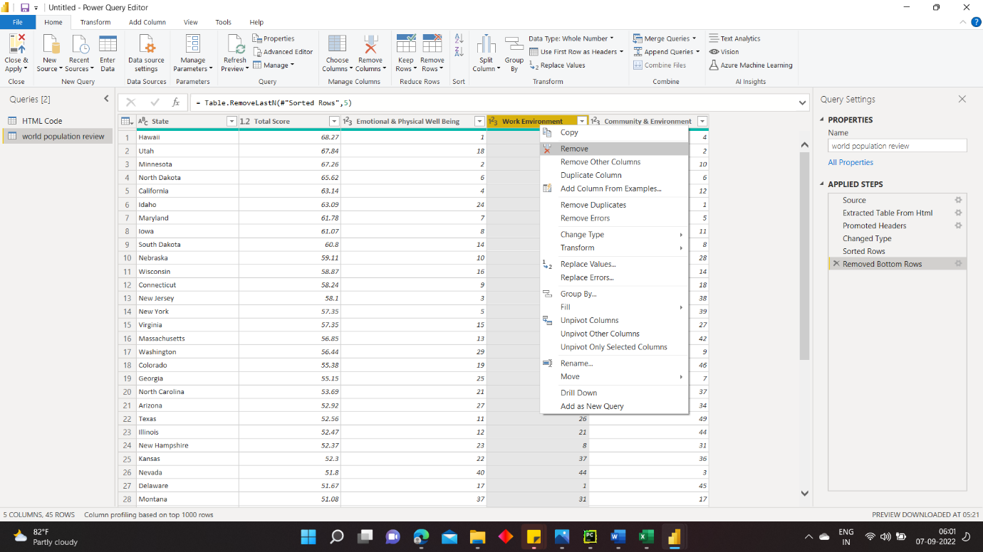

1. On second thought, **work environment** might be relevant to happiness after all. You'd like to get that column back.

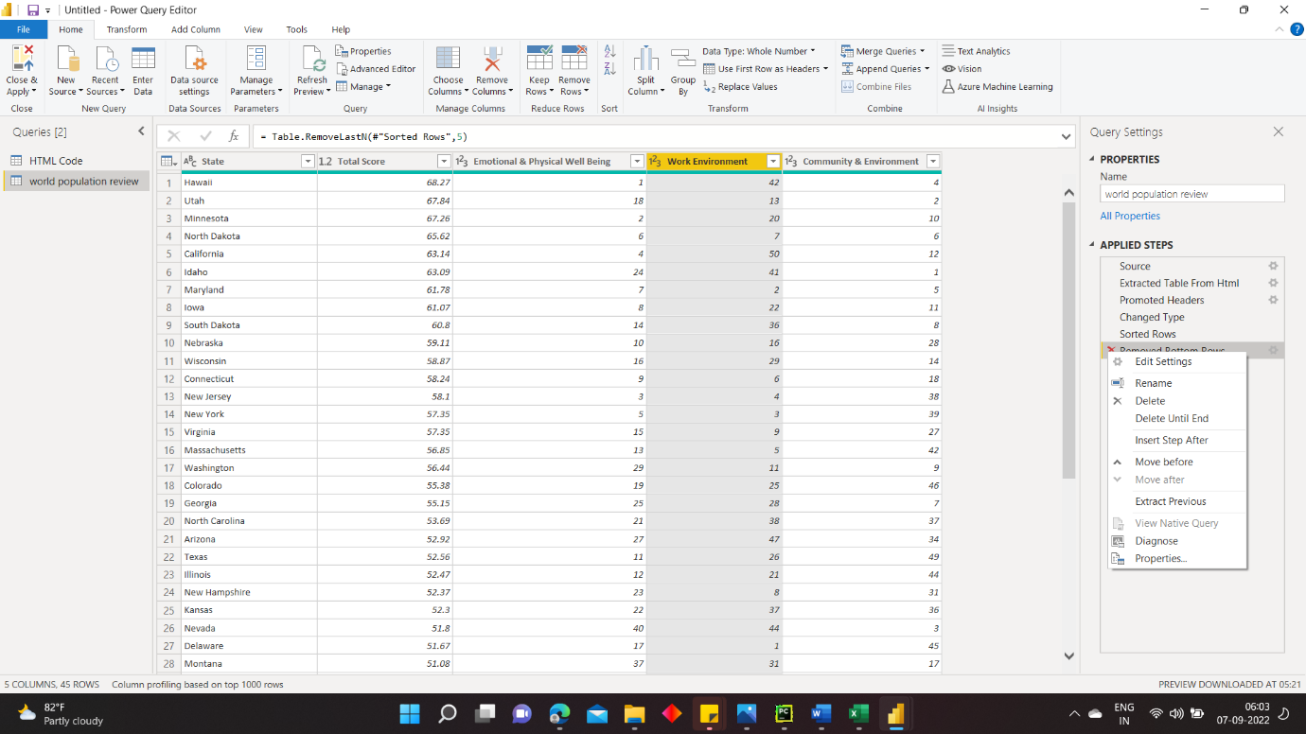

For example, if you no longer wanted to sort the table by **Weather**, you might try to delete the **Sorted Rows** step. Power BI Desktop warns you that deleting this step could cause your query to break. You removed the bottom 10 rows after you sorted by weather, so if you remove the sort, different rows will be removed. You also get a warning if you select the **Sorted Rows** step and try to add a new intermediate step at that point.

Finally, you change the table title.

**Properties** in the **Query Settings** pane, replace the old title with world population review.

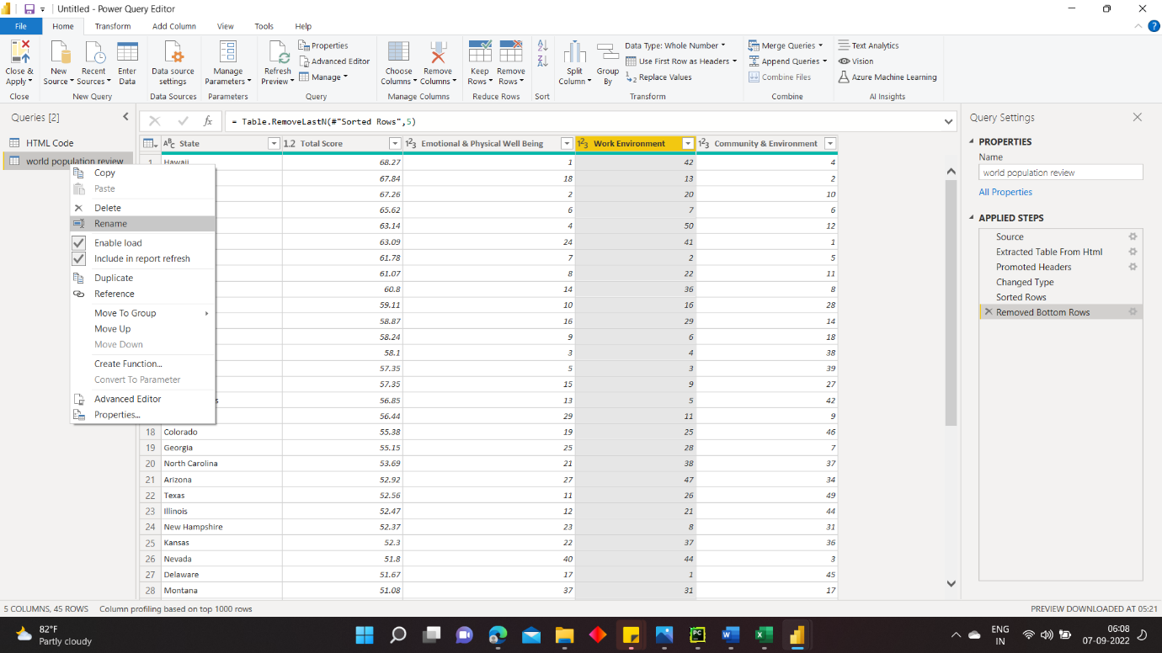

**Combine data**

The data about various states is interesting, and will be useful for building additional analysis efforts and queries. But there's one problem: most data out there uses two-letter abbreviations for state codes, not the full names of the states. To use that data, you need some way to associate your state names with their abbreviations.

You're in luck. Another public data source does just that, but the data will need a fair amount of shaping before you can *combine* it with your sunglass table.

To import the state abbreviations data into Power Query Editor, select **New Source** > **Web** from the **New Query** group on the **Home** tab of the ribbon.

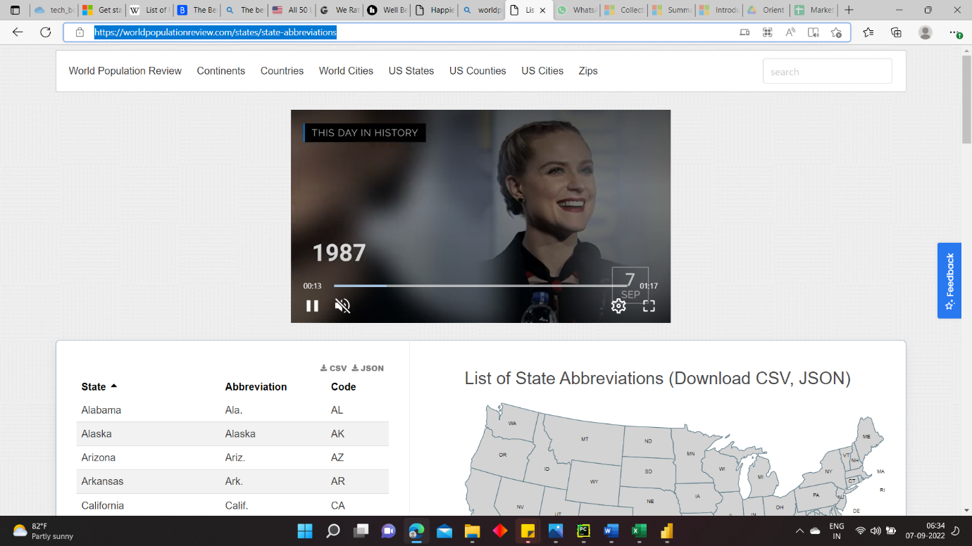

In the **Navigator** window, select the table  and then select **OK**. The table opens in Power Query Editor.

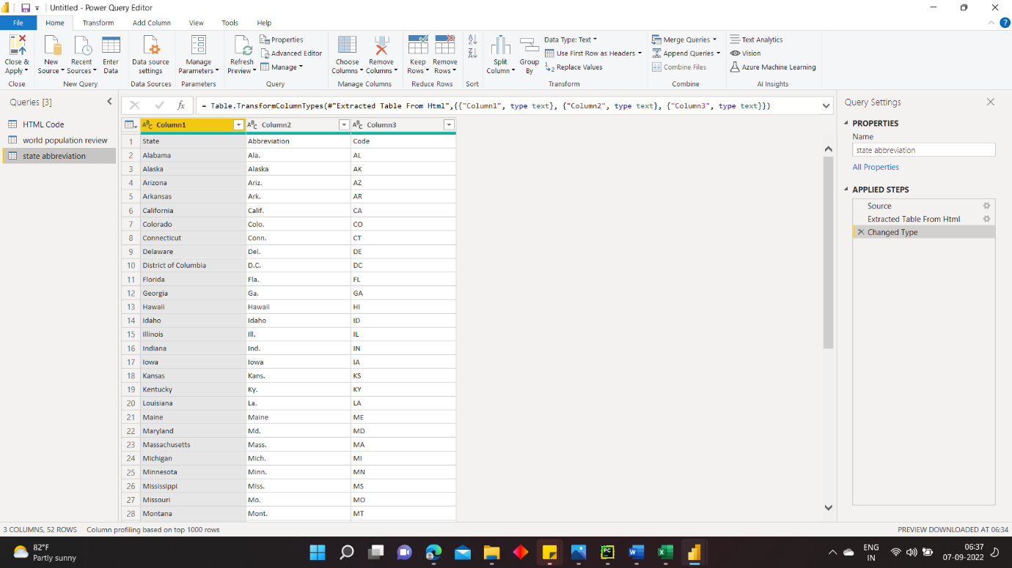

**Change first row as Header**

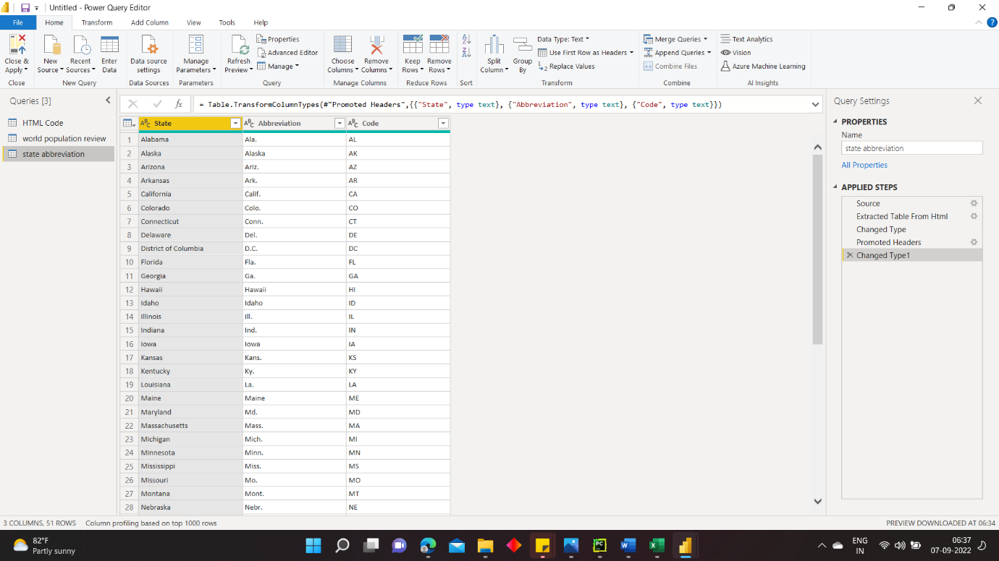

**DOUBT??????????????**

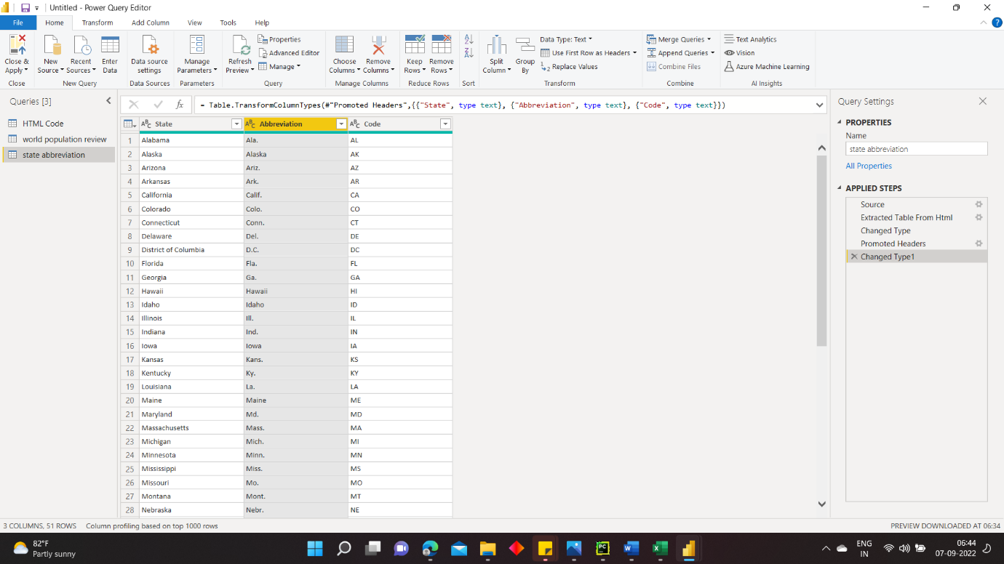

With the **State codes** table shaped, you can combine these two tables into one. Since the tables you now have are a result of queries you applied to the data, they're also called queries. There are two primary ways of combining queries: merge and append.

When you have one or more columns you'd like to add to another query, you merge the queries. When you have additional rows of data you'd like to add to an existing query, you append the query.

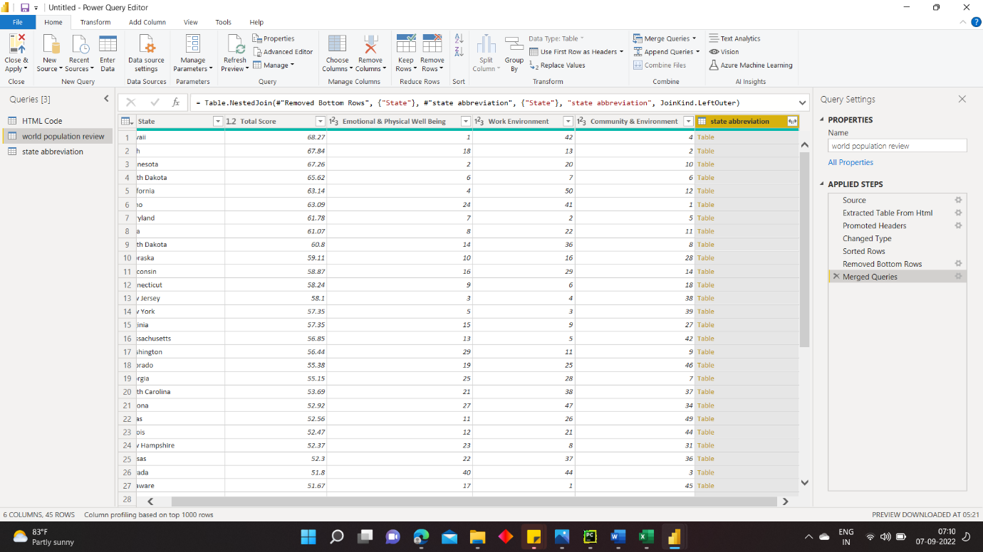

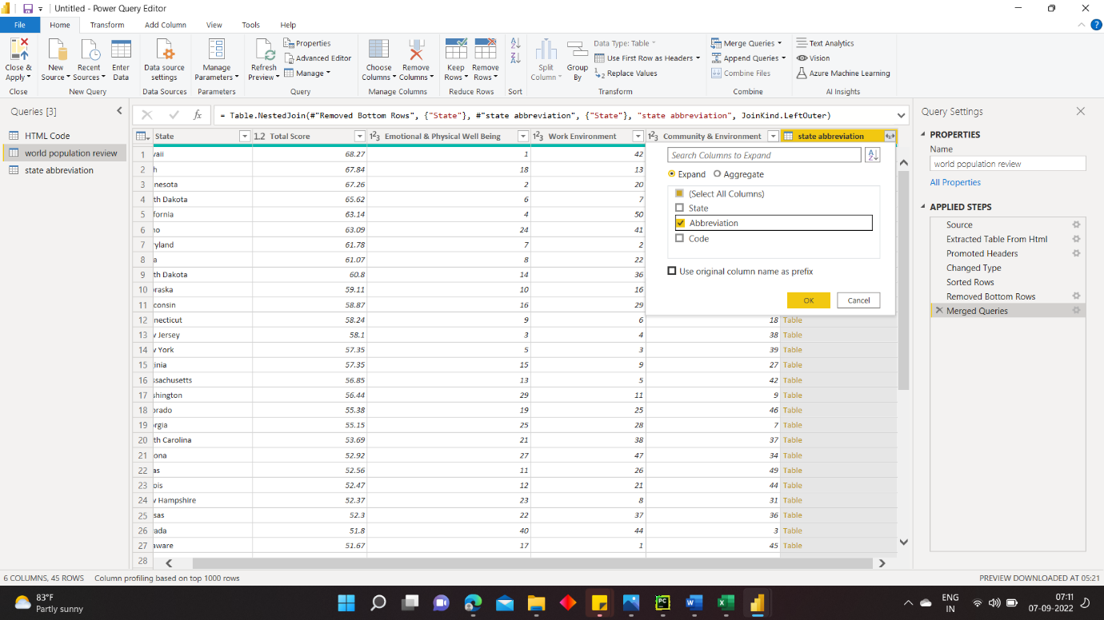

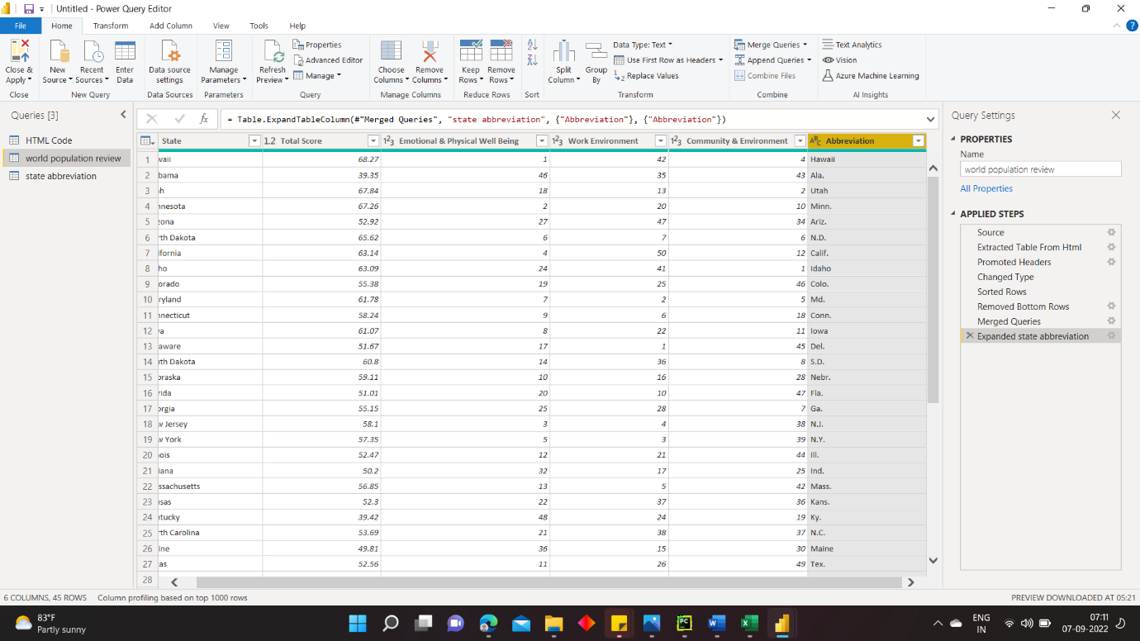

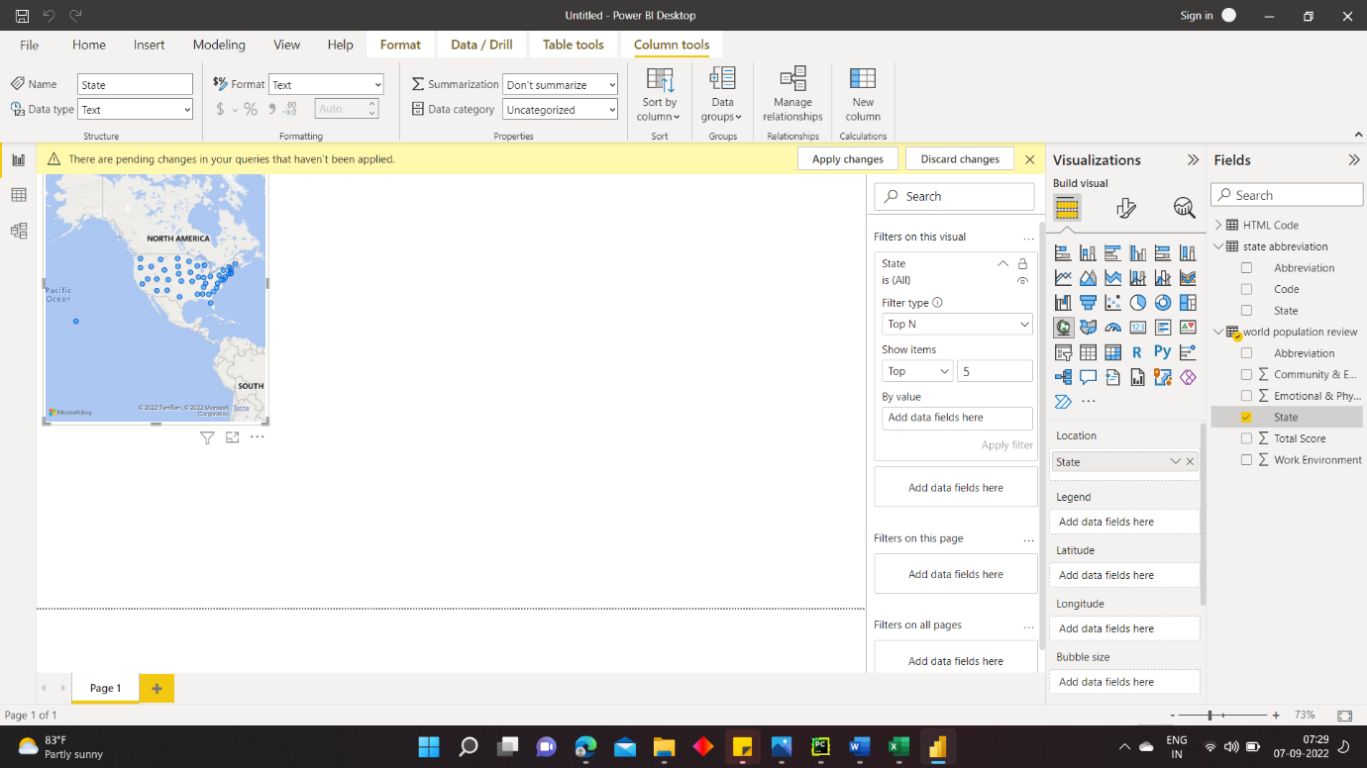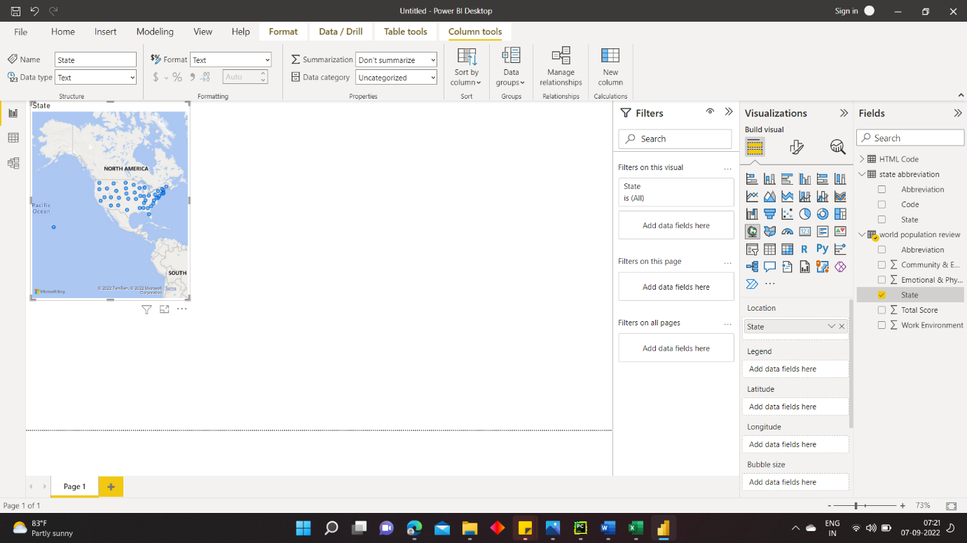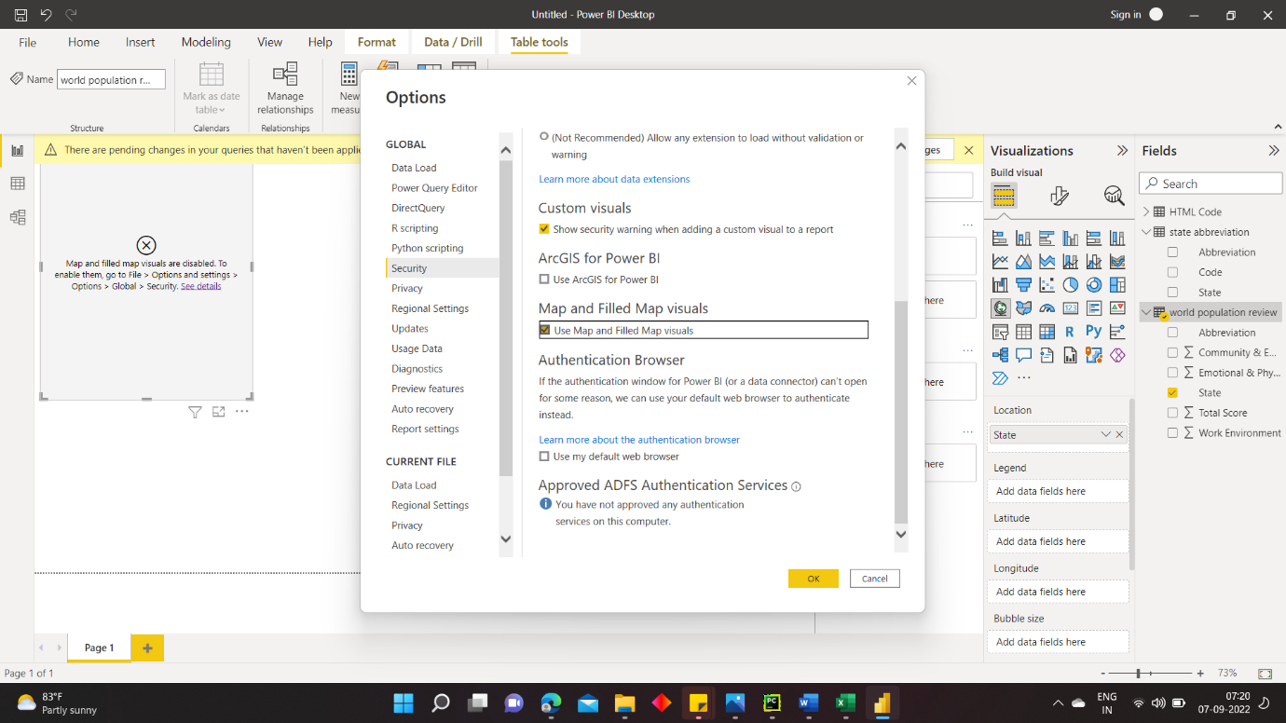

**DOUBT??????????**

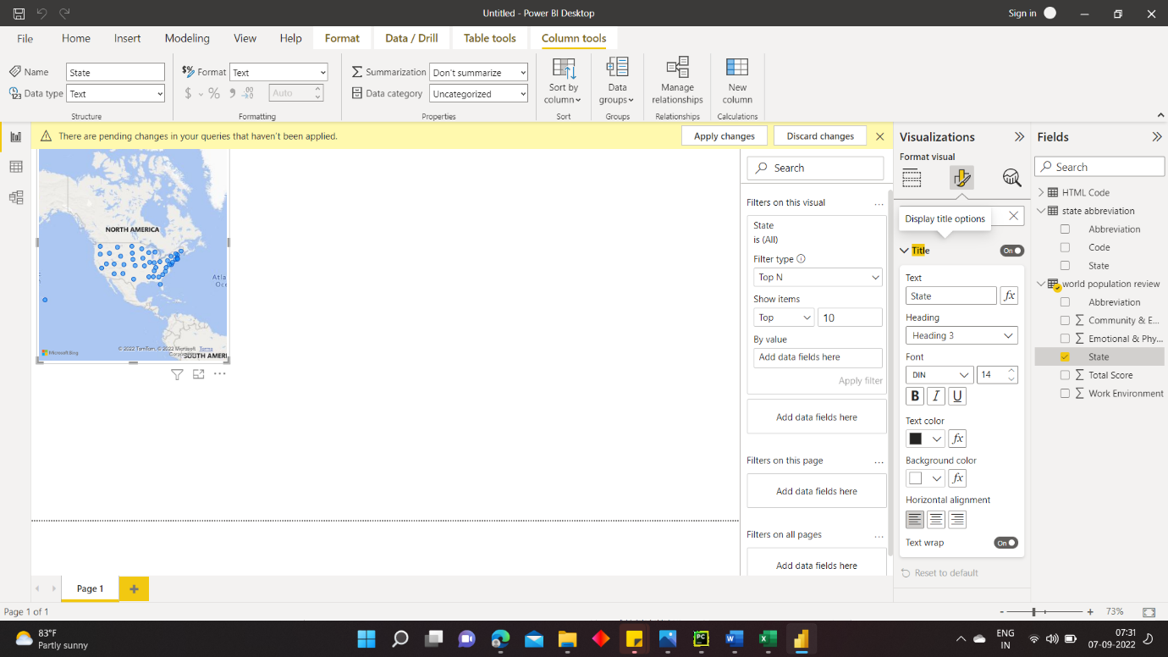



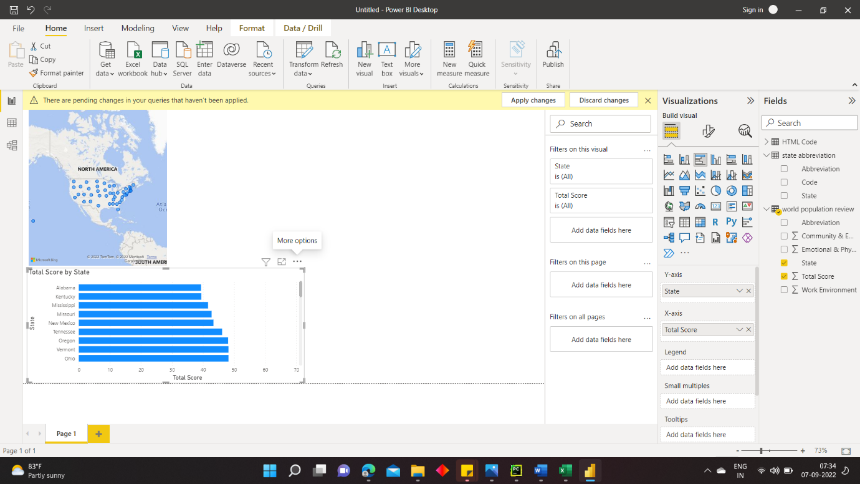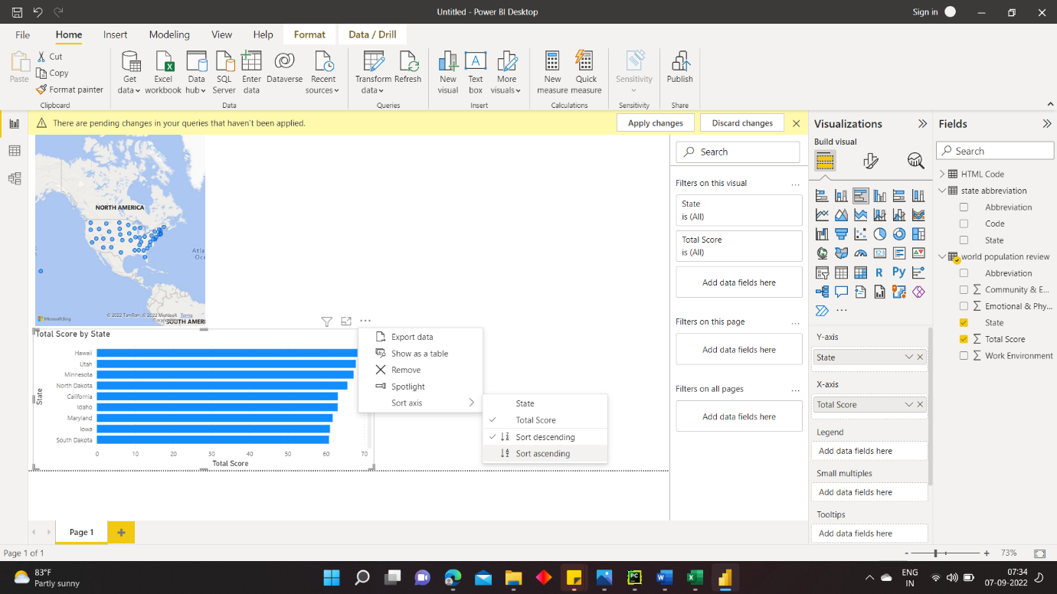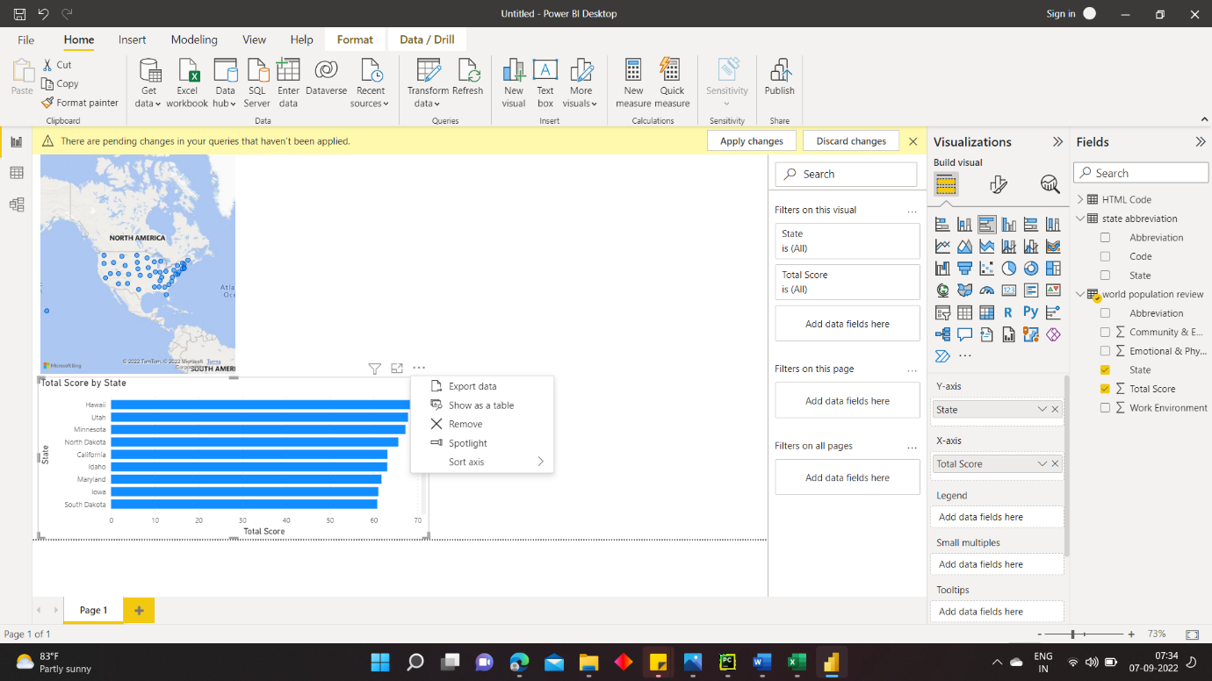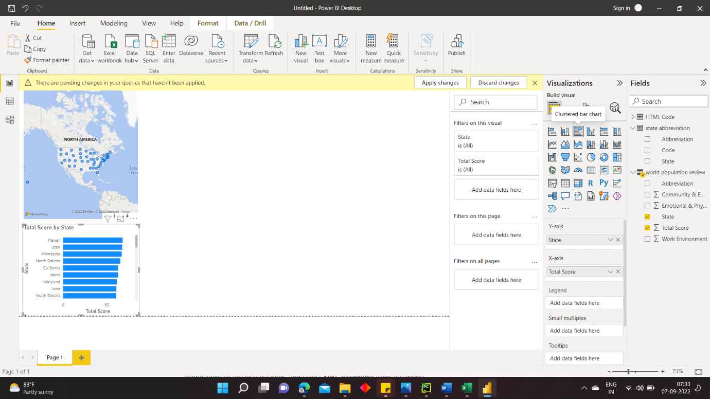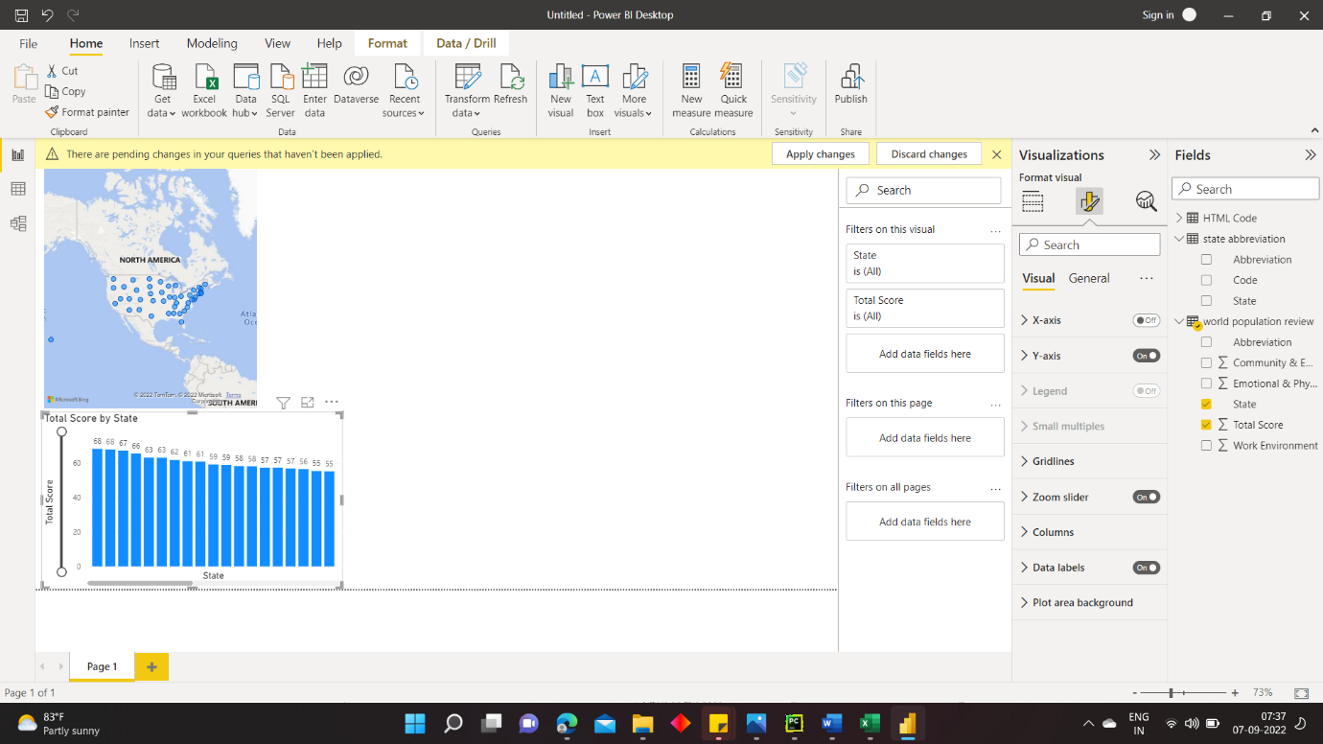

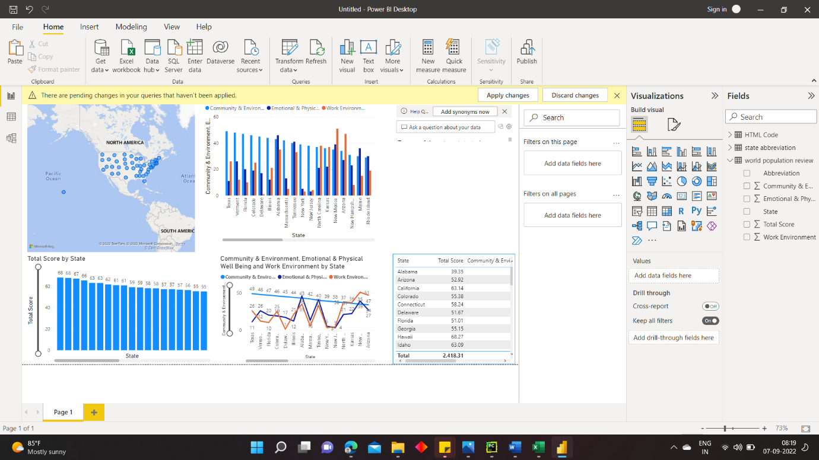

**Ask question:**

**Not able to filter top 10 data for total score.**